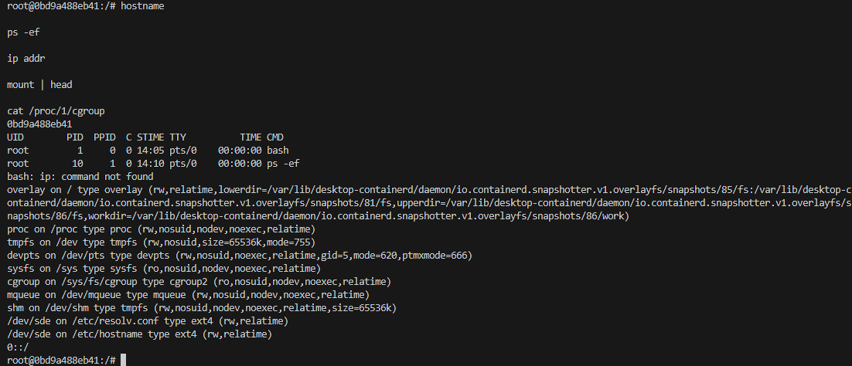

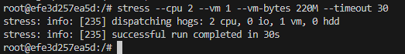
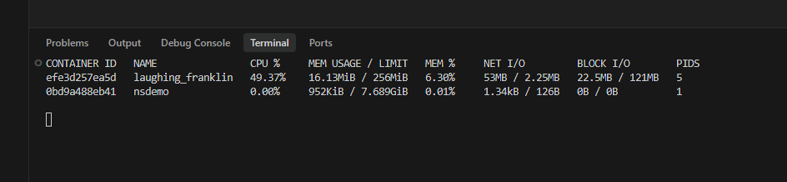
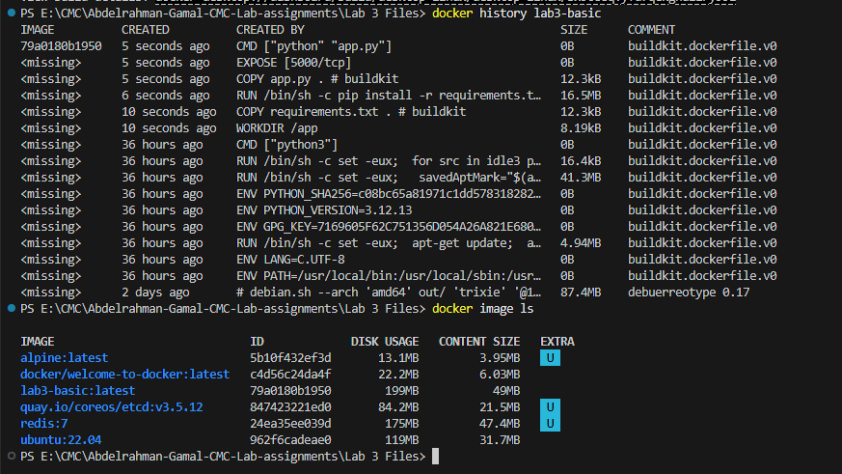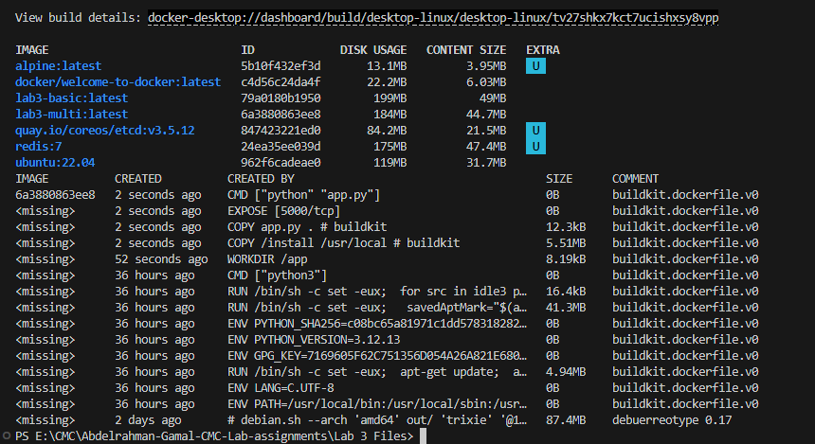
lab3-multi is smaller:
- lab3-basic: 199MB disk usage, 49MB content size
- lab3-multi: 184MB disk usage, 44.7MB content size

Which steps are cached if only app.py changes?
The earlier layers remain cached

Why does layer order matter?
Docker caches layers from top to bottom. If stable files like requirements.txt are copied before frequently changing files like app.py, Docker can reuse the dependency-installation layer on future builds. This makes rebuilds faster and avoids unnecessary work.
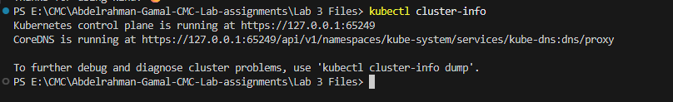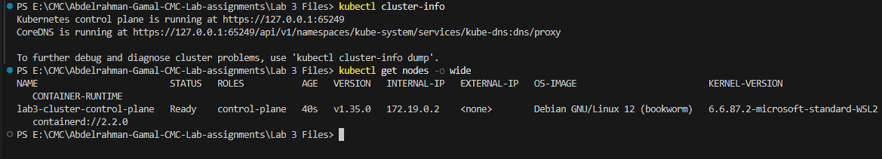
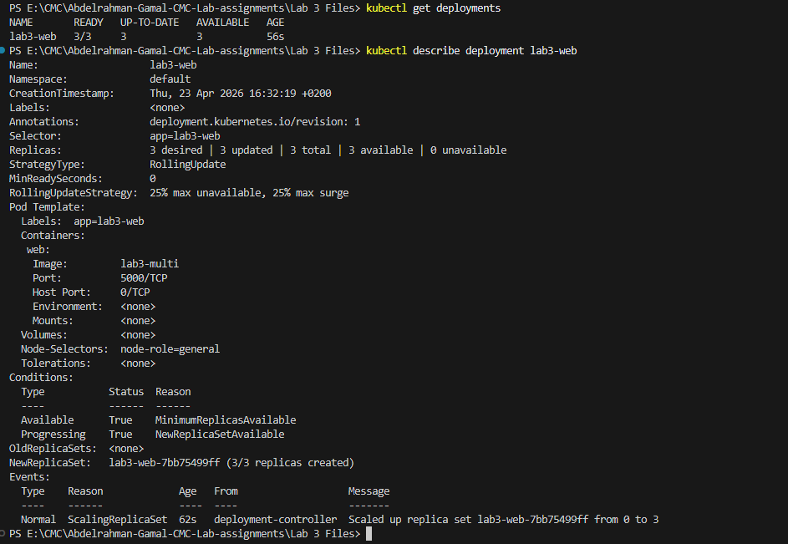
curl http://localhost:8080/
curl http://localhost:8080/health
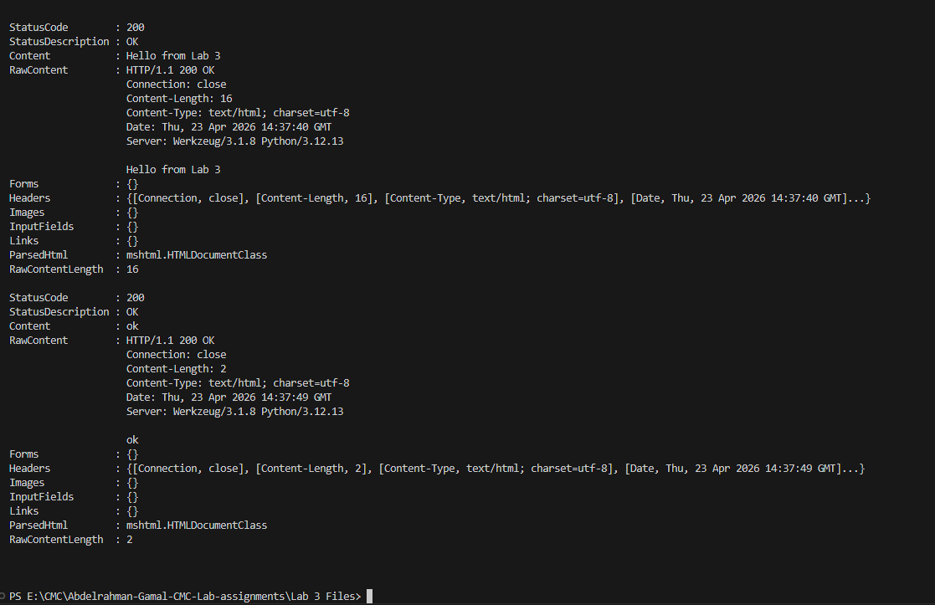

Part D
Answer:
This is different from hard-coding a machine name because the deployment targets a label-based property rather than one exact host. If the environment changes, any node with the required label can satisfy the rule. Declarative scheduling improves resilience and maintainability because the workload can still run if a specific machine disappears, as long as another suitable node exists. It also makes policies easier to manage at scale.

Part E
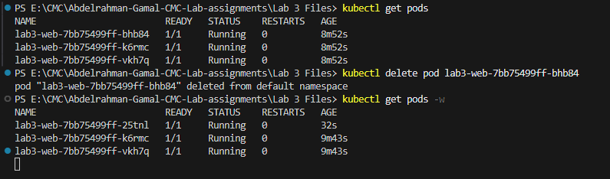
After deleting it added a new pod with different name
Answer:
This is called reconciliation because Kubernetes continuously compares the actual state with the desired state. When one Pod is deleted, the system notices the number of running replicas is below the target and creates a replacement. It is not just restarting a process blindly; it is restoring the declared system state.
 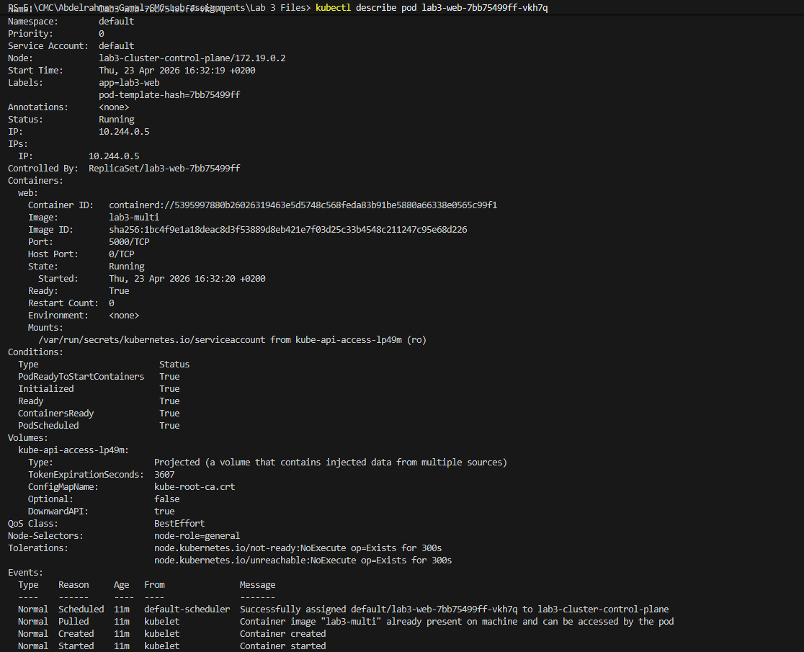
Dilevrable Questions:
Why does the container think its main process is PID 1 while the host sees a different PID?
Because of the PID namespace. Inside the container namespace, the first process is PID 1, but on the host it keeps its host PID.
How do cgroups complement namespaces?
Namespaces isolate visibility; cgroups limit resource consumption.
Which image is smaller?
Usually the multi-stage image.
Which steps are cached if only app.py changes?
The dependency installation steps are cached because requirements.txt did not change.
Why does layer order matter?
Because Docker reuses cached layers from top to bottom. Stable steps should go earlier.
Why is this called reconciliation rather than simple restart logic?
Because Kubernetes compares actual state to desired state and acts to restore the declared configuration.

